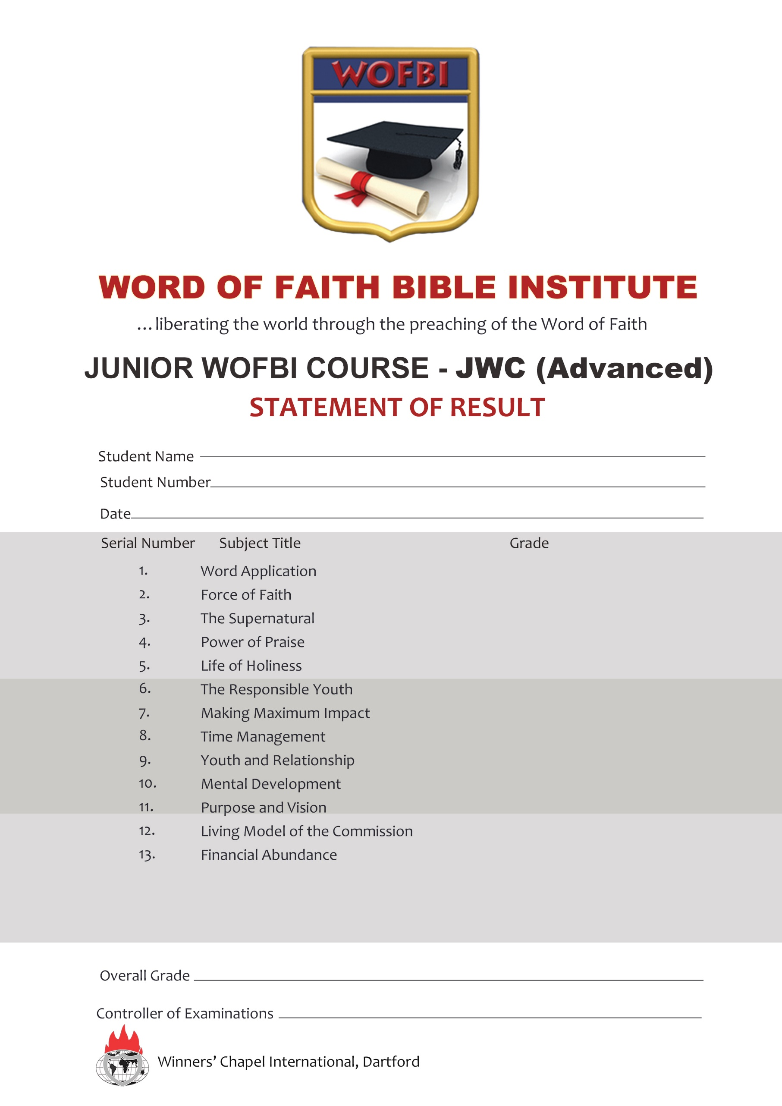
SUMMER JUNIOR BIBLE SCHOOL (BASIC)
STATEMENT OF RESULT
Student Name:
Student Number:
Date: 1st August 2025
Serial Number | Subject Title | Grade
1 | Putting My Mind to Work | A
2 | The Holy Spirit | B
3 | Understanding the Commission | A
4 | The Power of Choices | A
5 | Time Management | A
6 | Walking by Faith | A
7 | Effective Bible Study | A
8 | New Life in Christ | A
9 | Acceptable Christian Service | A
10 | Kingdom Wealth | A
11 | Living a Sickness Free Life | B
12 | Effective Prayer Life | A
*NS: No Show

Overall Grade: DISTINCTION

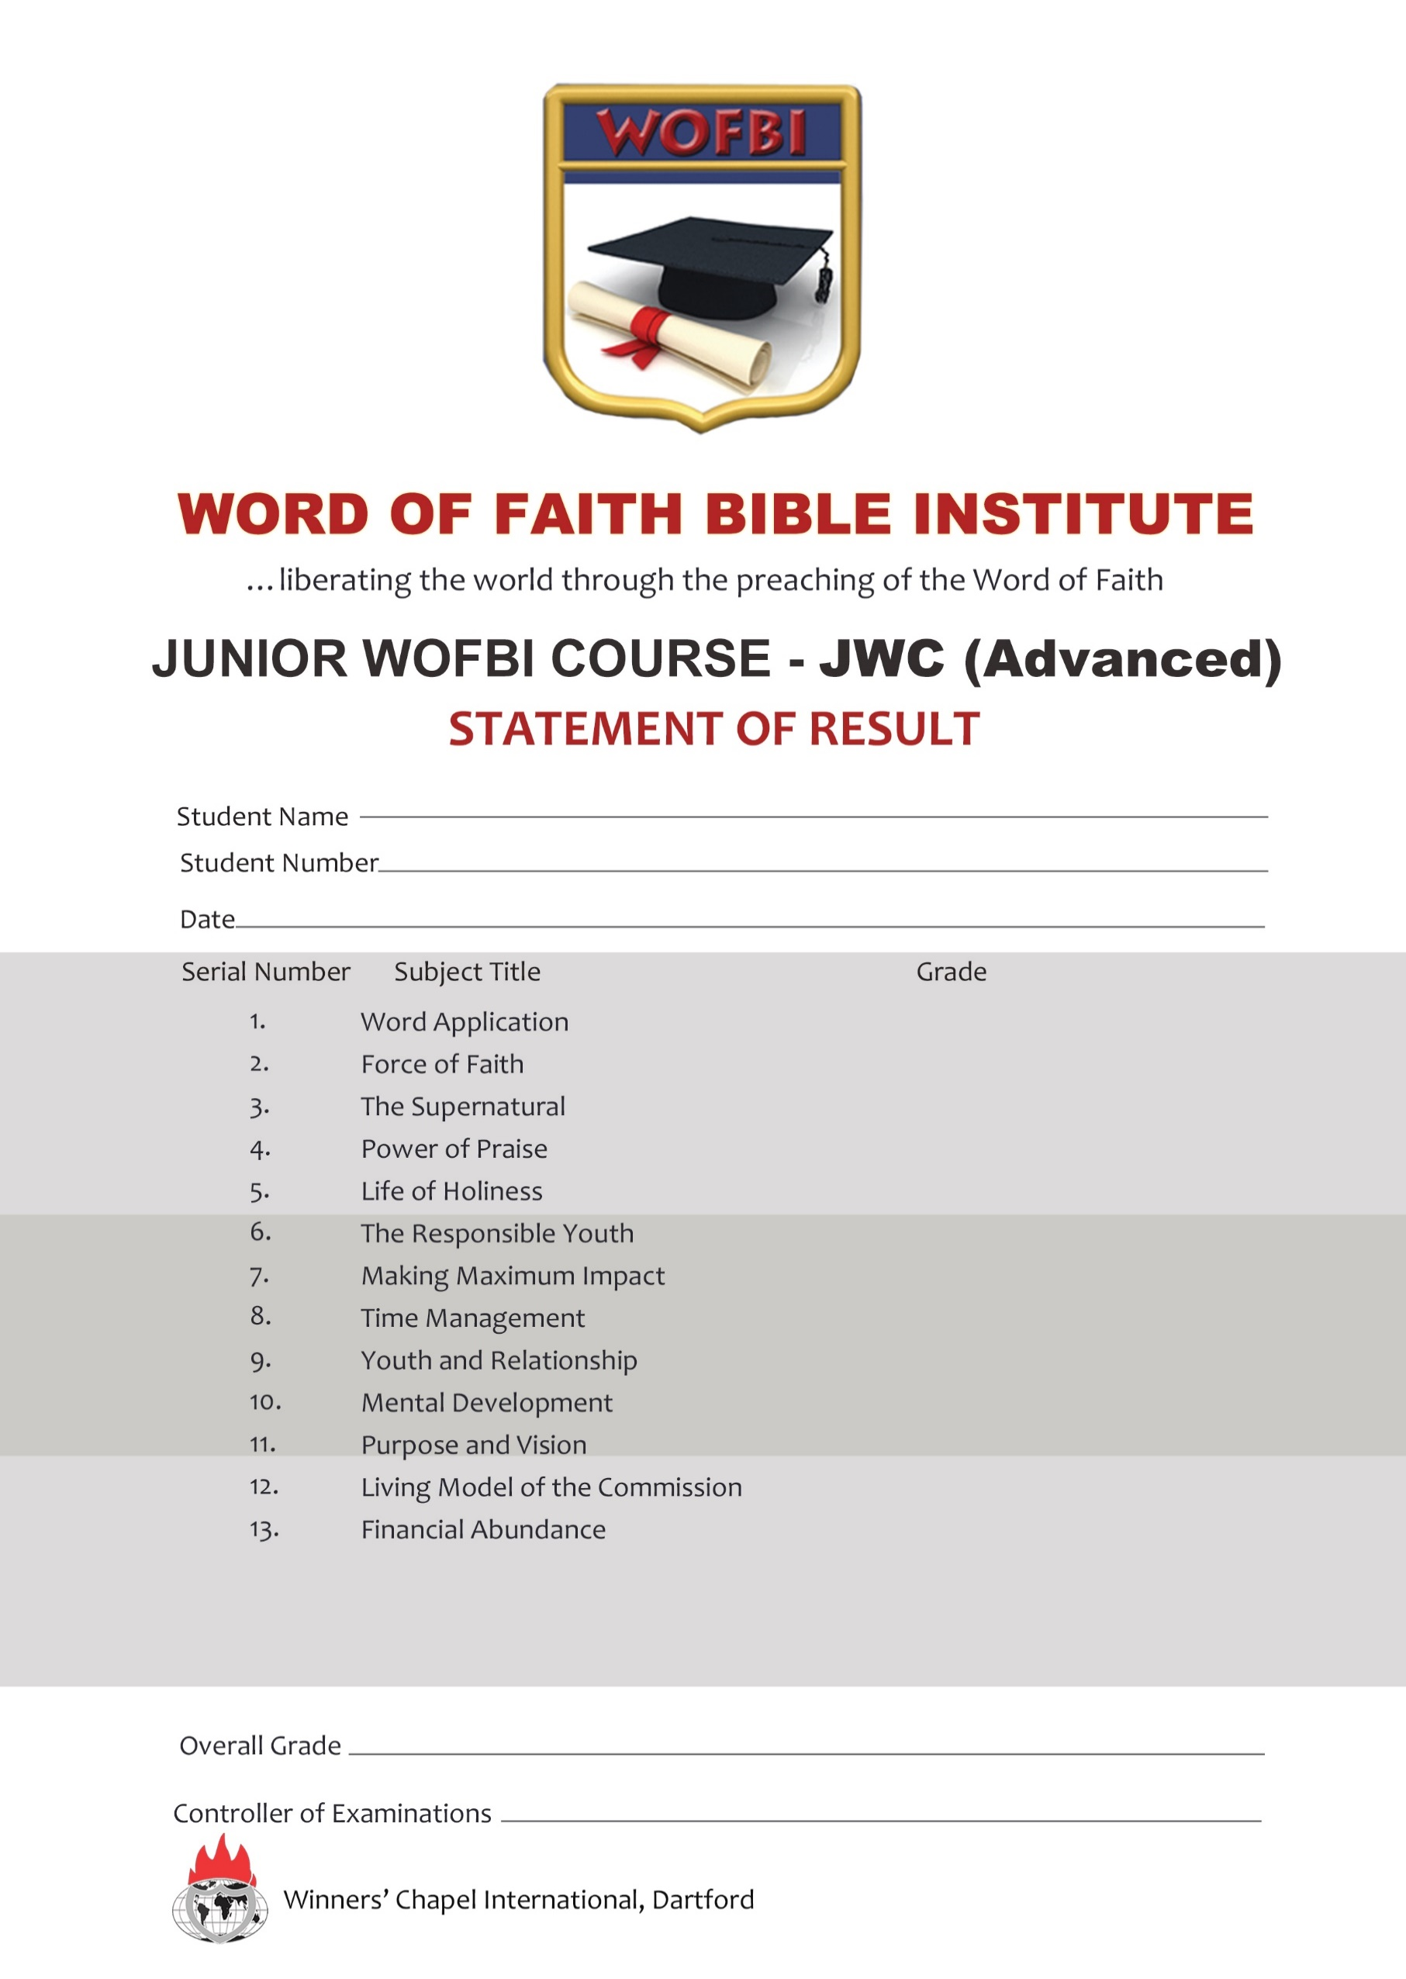
Controller of Examinations: ____________________________

